Spring Boot

It is a module in the spring framework which needs minimum configurations i.e, no XML file required at all.

It performs auto-configurations based on the libraries you have in your classpath

Spring boot released some of the starter libraries to perform these auto-configurations, some of them are:

1. spring-boot-starter-web
2. spring-boot-starter-aop
3. spring-boot-starter-jpa
4. spring-boot-starter-actuator
5. spring-boot-starter-devtools

These starters takes care of auto-configurations for your applications.

i.e., starter-web will configure a server, dispatcher servlet, view resolver, annotation based configurations, component scanning

starter-jpa will configure all the dependencies required for the databases and scans all the entities, however you need to provide datasource informations in the application.properties

Resolving Version mismatch

Spring boot has a *spring-boot-starter-parent* POM that has all the list of compatible starters according to the spring boot version

i.e., if you add spring-boot-starter-parent version 2.3 then any starters of spring boot like web, or jpa doesn’t need to mention the version number, because spring boot pulls the compatible version of web or jpa as per the starter-parent.

Note: Spring boot can be done only through either Maven or Gradle

There are two ways you can create project to use spring-boot

1. Maven project with spring boot parent starter
2. Maven project downloading from spring initializr (better)

Maven project by manually selecting the spring boot starter parent and mentioning some dependencies

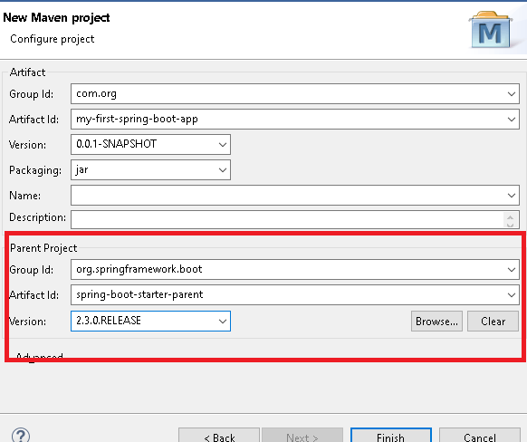

pom.xml

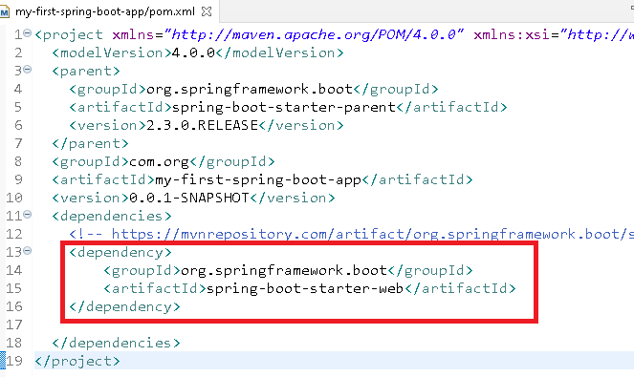

Application.java

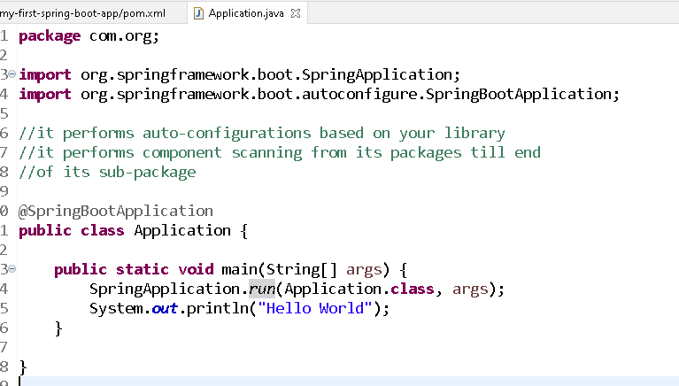

@SpringBootApplication will do auto-configurations like

* stating a tomcat server
* component scanning from its root package
* configuring dispatcher servlet
* reading application.properties & configuring the application

application.properties file should be created inside src/main/resources folder, however you can have yml file instead of properties i.e, application.yml

You can add spring boot devtools to automatically reload your application on server

pom.xml

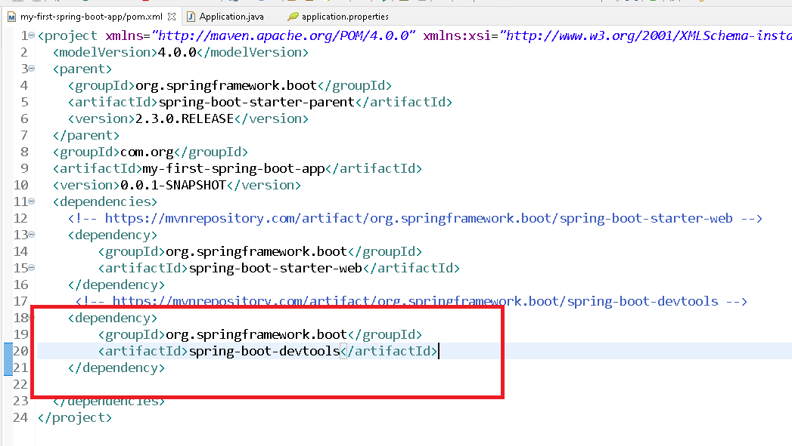

create application.properties inside the src/main/resources

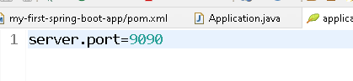

You can create a controller using @Controller because of auto-configuration feature DispatcherServlet will be configured and you can use controller directly.

Adding JSP files to your spring boot project needs lot of configurations.

In pom.xml you add two dependencies and also change the <package> to war

1. tomcat embedded jasper
2. ecj

pom.xml

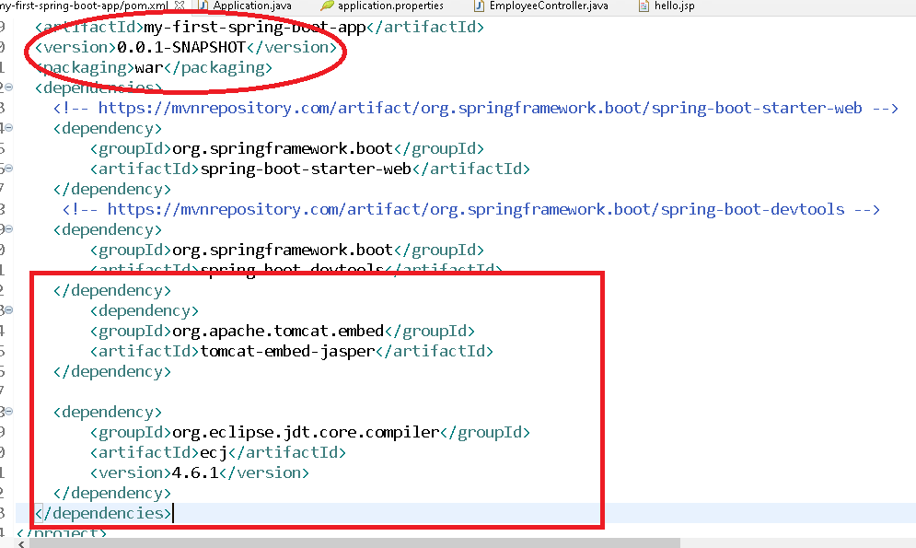

Add view resolver properties in pom.xml

application.properties

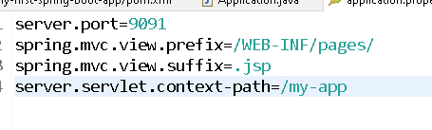

Create a controller

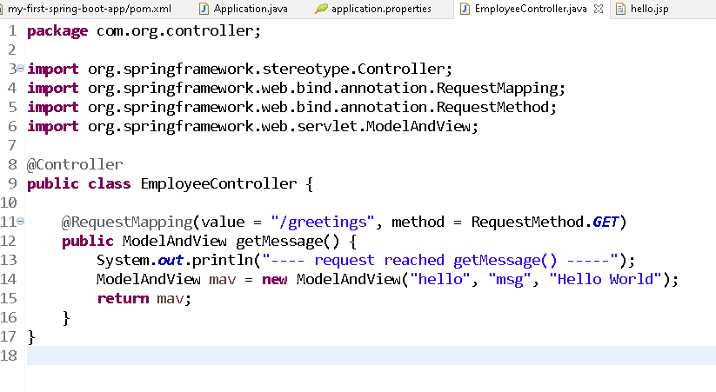

You can use yml files instead of properties because it avoids you using repeatable properties.

Note: yml files use indentation to recognize the nested properties

Delete the application.properties & create application.yml

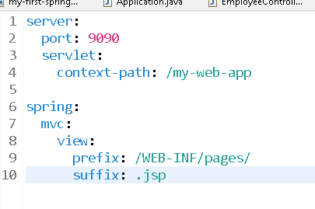

Creating the project using spring initializr

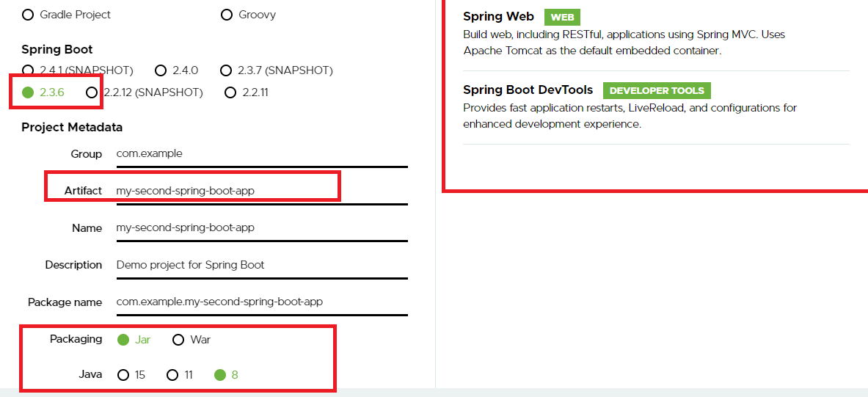

When you use spring initializr you will get a Java file that launches the spring boot application and also an application.properties where you can configure the application configurations like port, server address, datasource, context-paths, actuator informations, you can create yml file by deleting the properties file.

How to run/launch the application in the production

Inorder to launch the application in the production you need a deployable war/jar, since you have created project through spring initlializr it gives you deployable jar/war.

You need to use mvn commands to build a jar and run the jar

mvn clean: deletes the target directory

mvn package: compiles and creates the executable file

java -jar target/file.jar --server.port=9093

Note: All these commands you need to enter from the project locations

You can add different servers other than tomcat like jetty server, but you must exclude the default tomcat server in the web dependency

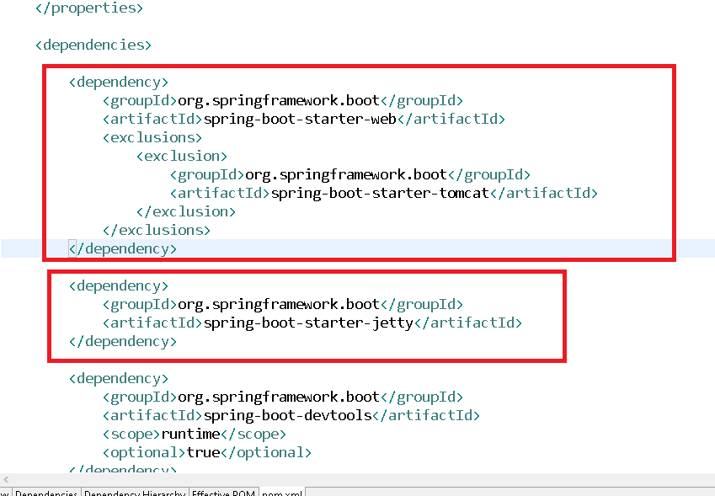

Output:



You can also use undertow servlet container

It is servlet container form jboss

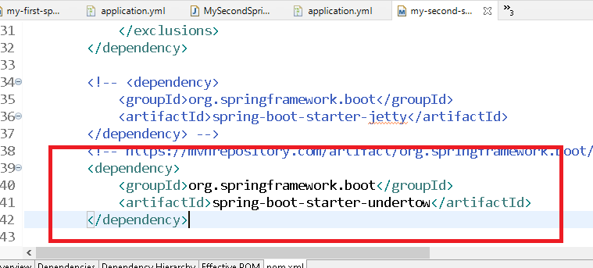

Output:



Building webservices in Spring Boot

Webservices: These are online services that are exposed for other applications to call

ex:

1. Banking applications expose checkBalance, debit, credit functionalities to the applications like google pay, phone pay, paytm
2. Google map has exposed its location services to the applications like Uber, Ola, Zomato and also to the public customers

How to build webservices

1. REST stands for REpresentational State Transfer, where you exchange the state(data) in JSON/XML/Text Representations and transfer between the each other applications
2. You must have a class with @RestController
3. Inside the RestController you must have methods that can handle different type of http request and URI
   1. GET
   2. POST
   3. PUT
   4. DELETE

Client applications

These are the applications which will have some programs to call the webservices and convert the response of webservices to the format they can understand.

ex: Google Pay is a client to many banks, Google pay takes care of converting JSON to the language Google pay is written in similar way what google pay sends to banks is also converted to the language the banks is written in

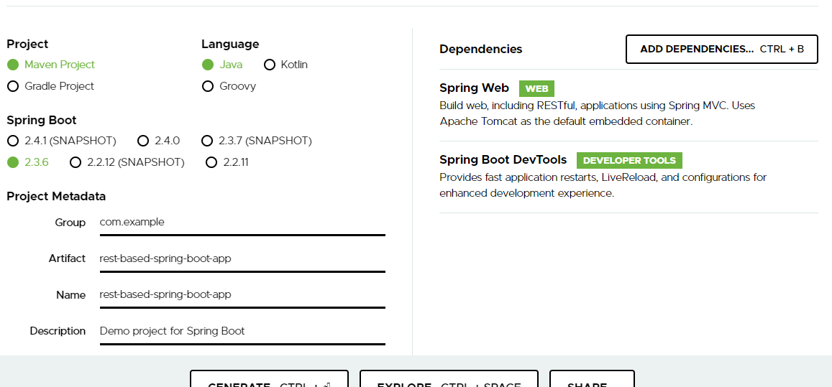

application.yml

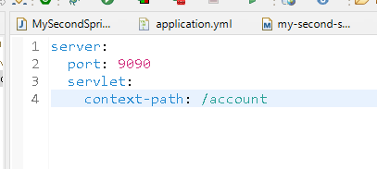

Account.java

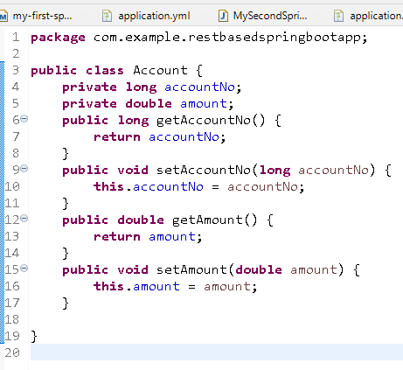

AccountController.java

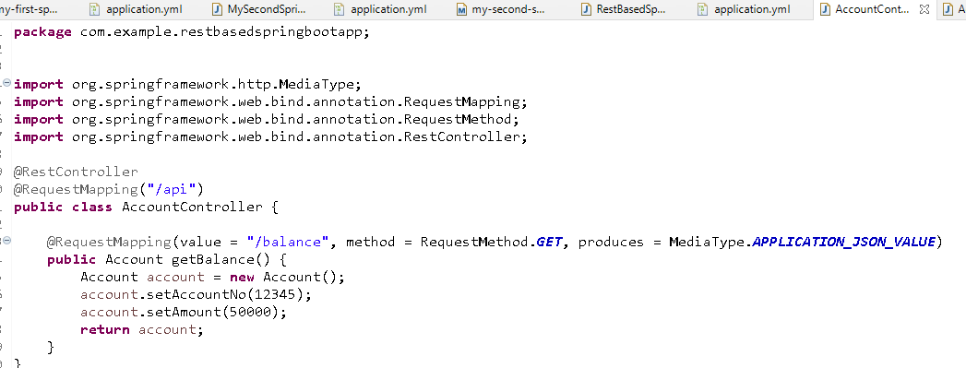

Output:

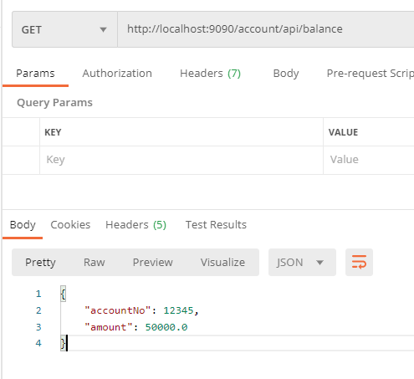

XML response: It is not a default response hence you need to use @XmlRootElement on top the java class that needs xml representation

Account.java

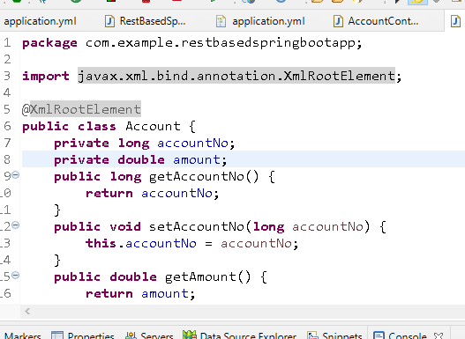

Output:

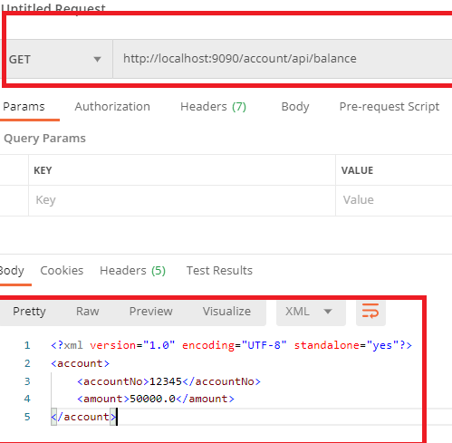

You can send the response in multiple formats

However the client needs to mention in its request headers what is the response it needs using accept-type

Content Negotiation: Client mentions in the request header what format it is expecting

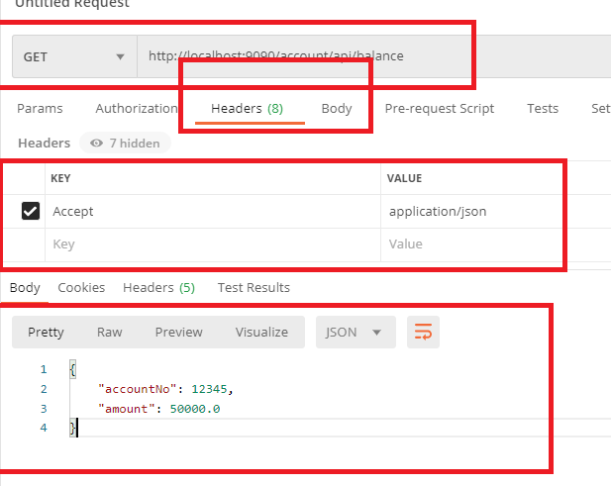

@PathVariable: it can extract the inputs from the URI

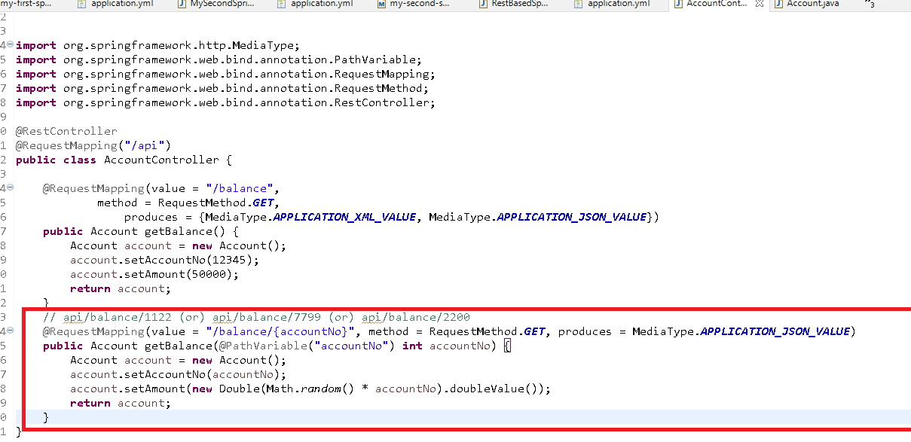

Output:

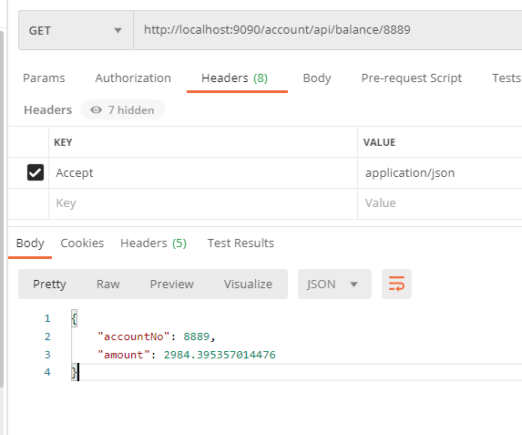

You can use common uir’s for multiple webservices but it must have different HTTP methods

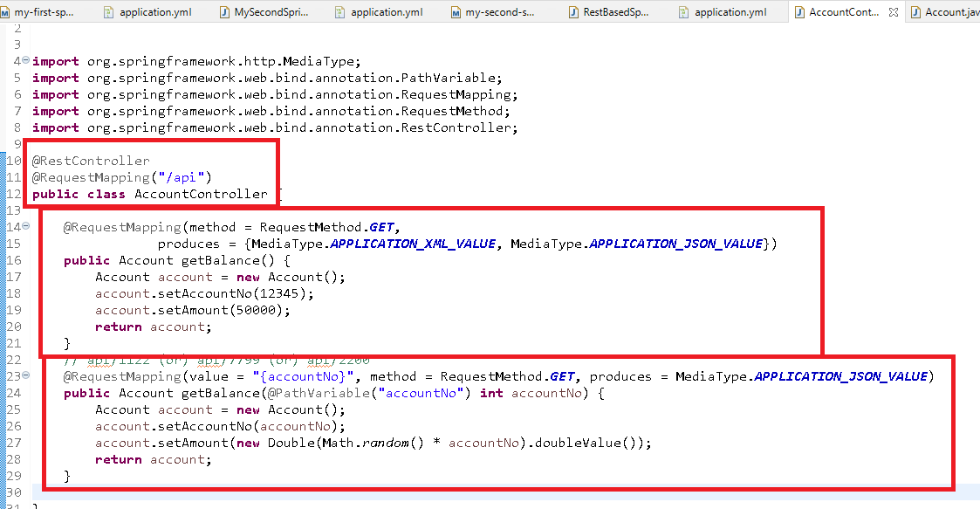

Output:

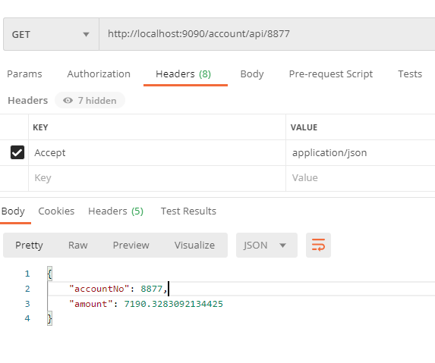

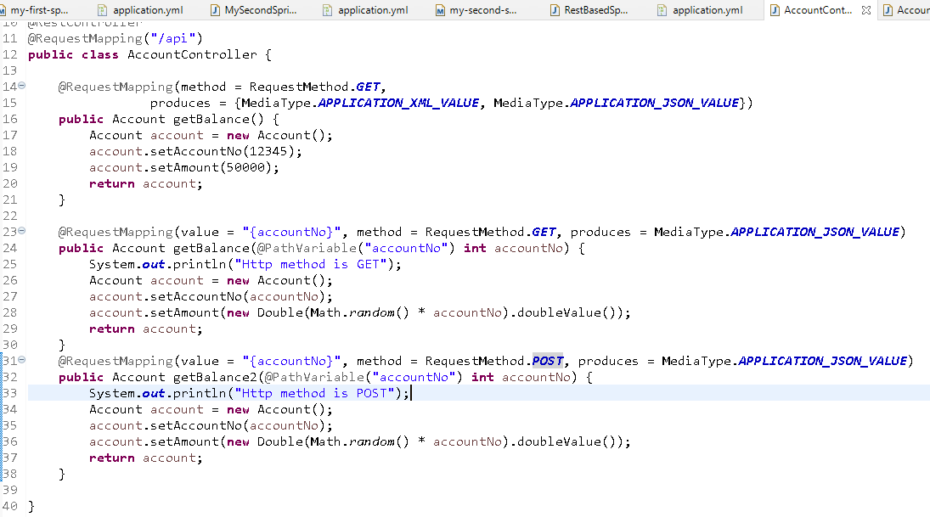

Above webservices can have same URL’s but different HTTP methods so that client can use different HTTP methods for same URL

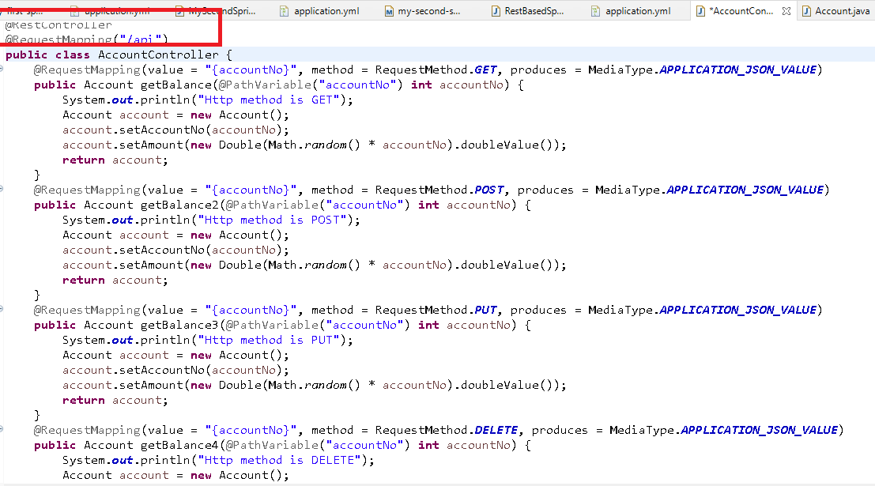

Above webservices take same URI’s but different HTTP methods

HTTP methods are useful like contract between the client & the server

1. GET: fetching the resource
2. POST: creating the new resource
3. PUT: updating the existing resource
4. DELETE: deleting the existing resource

Spring Boot also gives annotations for different HTTP methods

@GetMapping

@PostMapping

@PutMapping

@DeleteMapping

